<https://www.skillshare.com/>

P a r t I N e w R e p o s i t o r y ?

**Git clone <repo_path>**

this will generate a .git folder which helps you to communicate further with git repo.

(These git commands won’t work if you are in a folder which does not have .git folder)

**Ls**

list all your files inside of a folder

**Git status**

tells is untracked files which are not part of files stored in git repo. It also tells you which file has been modified and needs to be committes.

**Git add <file_name>**

to add a particular file to staging area for it get uploaded at git later on.

**Git add.**

if you have multiple files which are updated and you want to commit all at once.

Now if you run “git status” command, you will see the list of new files added with “git add” command and message if the git repo is up to date

**Git commit**

executed after “git add” and it says, hey I am committing that these are the changes that I want to make to github.

You can also add a message with your commit so other people working on same repo will be able to see why and what has been commited, so to do that add “-m <message>,

Git commit –m “<message>” [this has to be done together, not like you run git commit and add message later]

**Git push**

to load committed changes to github.

**Git pull**

to pull whatever is the latest in the github. This command will make changes to your local files as per latest code present in github

P a r t I I B r a n c h I n g

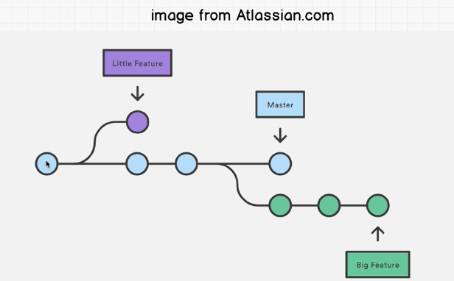

**Git branch**

shows you the branches and also highlights the one which you are on with ( * ).

**Git branch <branch_name>**

to create a new branch

**Git checkout <branch_name>**

to switch to another branch

Now, you made some changes in your new branch -- > committed and pushed the changes to git

If you go on github, click on button – Compare & Pull Request

There you can leave a message for other team members and create a pull request.

Your teammate sees the changes, review and approve it by leaving a message in review changes section. After that is done, a button Merger Pull Request will let you merge changes to the master branch.

**git merge master:**

When you are working on a feature and branch and you don’t want to miss out on the updates that other developers have made.

---------------------git merge master vs git pull---------------------

git merge master: it happens between two git branches

git pull: it happens between code in your local and code in github

---------------------MERGE CONFLICT---------------------

**Git checkout titleFeatureBranch == > git merge master**

This says, hey! Merge whatever is there in master with titleFeatureBranch

In case of MERGE CONFLICT between titleFeatureBranch and master branch

You may see in your local files,

<<<<<<<HEAD == > this shows the line where you branch is at.

So starting from “<<<<<<<HEAD” till you see “=========” shows the code which you have in your local and after “===========” till “>>>>>>> master” you’ll see the code which is there in the master branch.

So you’ll have to,

1. discuss with team and make changes in your local and
2. Remove “<<<<<<<HEAD”, “=========” and “>>>>>>> master”
3. then push the changes to your branch

**git remote add origin https://github.com/wittyveins/Notes.git**